Introduction

Why need AI?

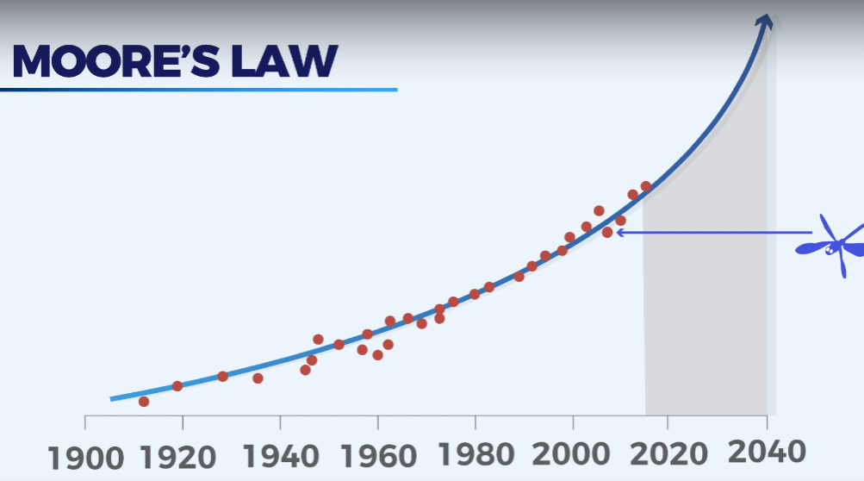

Exponentially increasing the need for AI

Extra additional Resource - <https://www.tfcertification.com/pages/artificial-intelligence>

Structure Syllabus

* Part 0 - Fundamentals of Reinforcement Learning  
  - Q-Learning Intuition  
  - Q-Learning Visualization
* Part 1 - Deep Q-Learning  
  - Deep Q-Learning Intuition  
  - Deep Q-Learning Implementation  
  - Deep Q-Learning Visualization
* Part 2 - Deep Convolutional Q-Learning  
  - Deep Convolutional Q-Learning Intuition  
  - Deep Convolutional Q-Learning Implementation  
  - Deep Convolutional Q-Learning Visualization
* Part 3 - A3C  
  - A3C Intuition  
  - A3C Implementation  
  - A3C Visualization